Function Check List
 | Functions | Showcase
V | - Customer Profiles  Manage creation, updating, and deletion of customer profiles. | 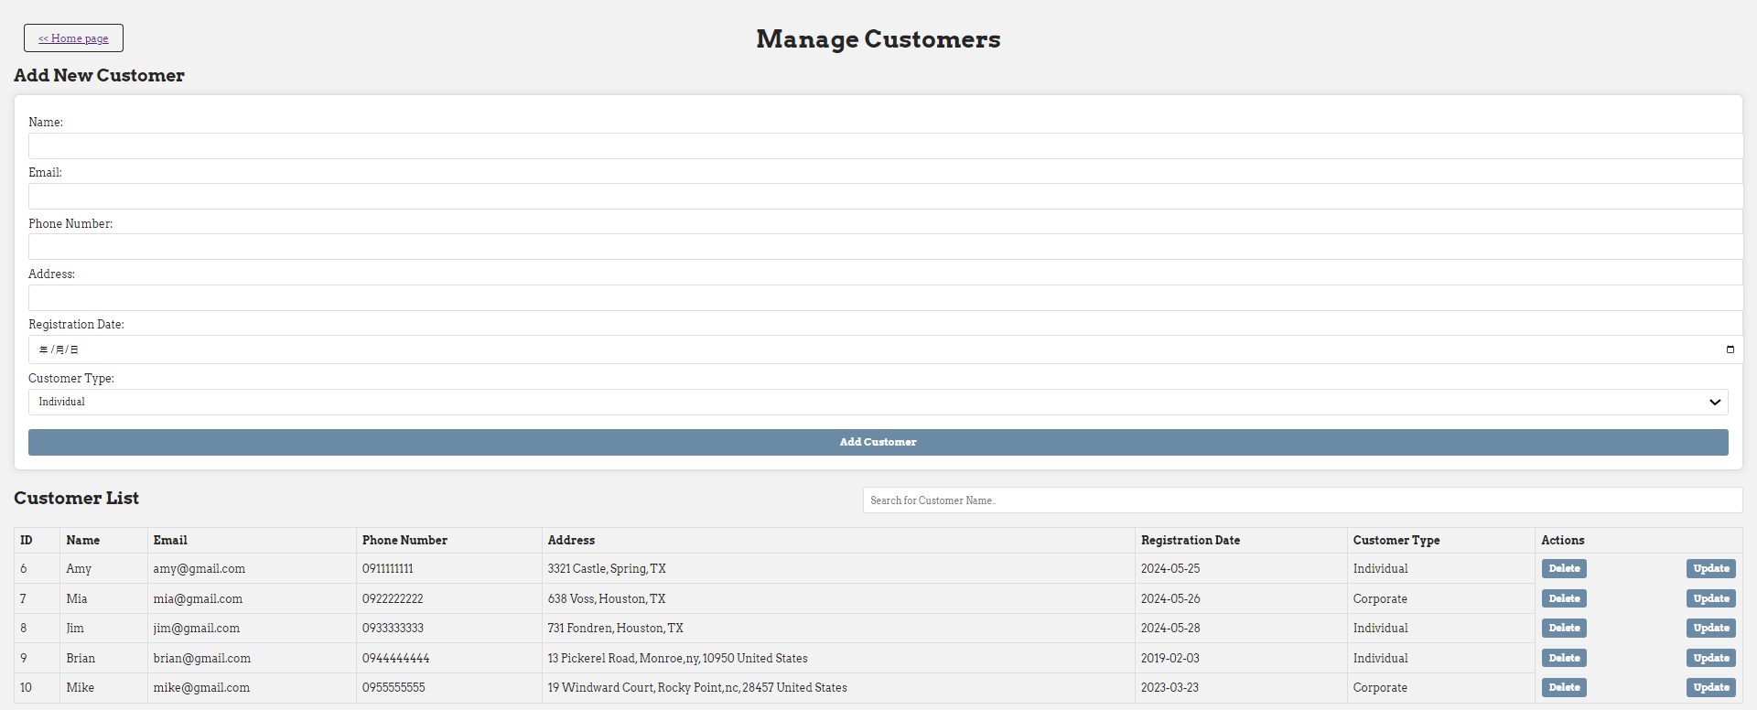
V | - Sales Tracking  Process and track sales orders, manage inventory updates(stock quality in products), and handle payment and delivery statuses. | 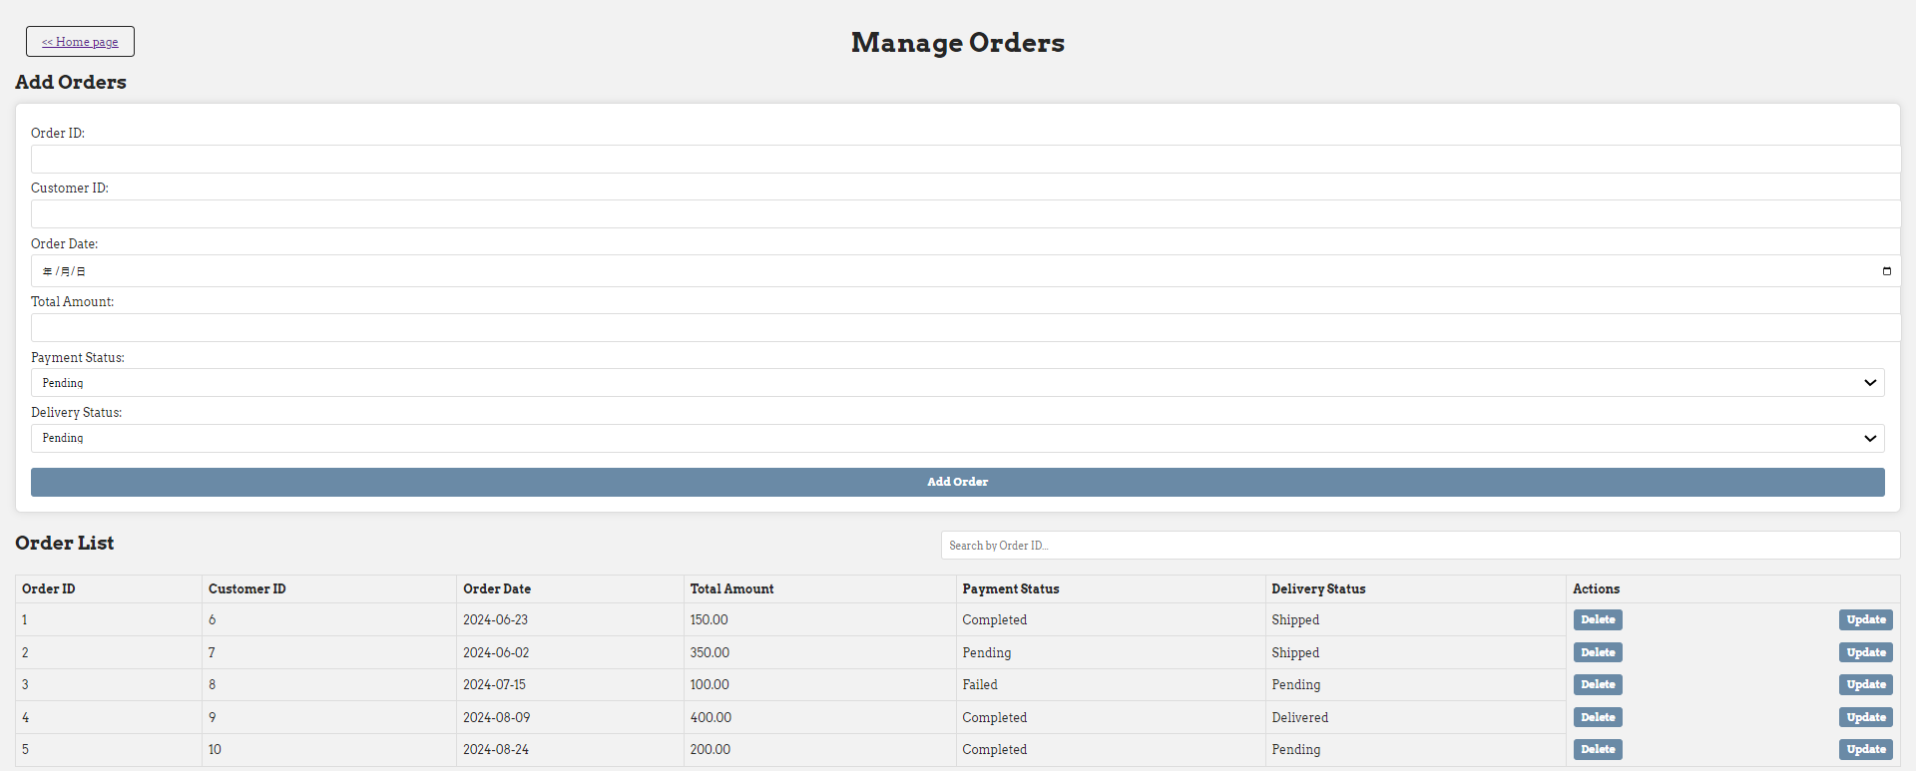  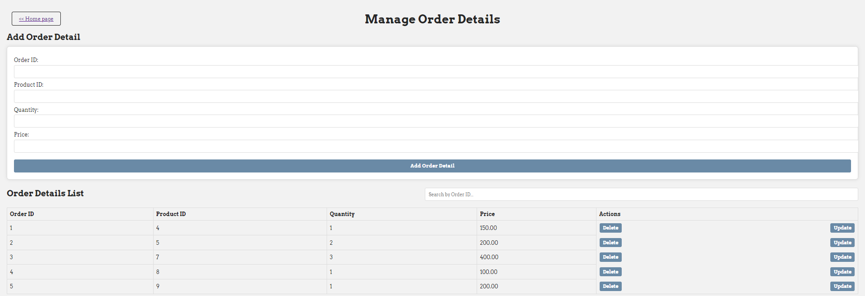
V | - Product Management  Maintain product information, manage stock levels, and categorize products. | 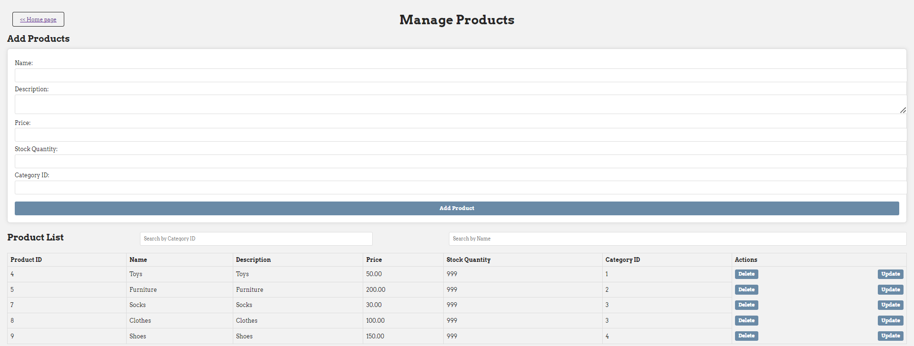
V | - Customer Service  Handle service requests, track status updates, and manage resolutions. | 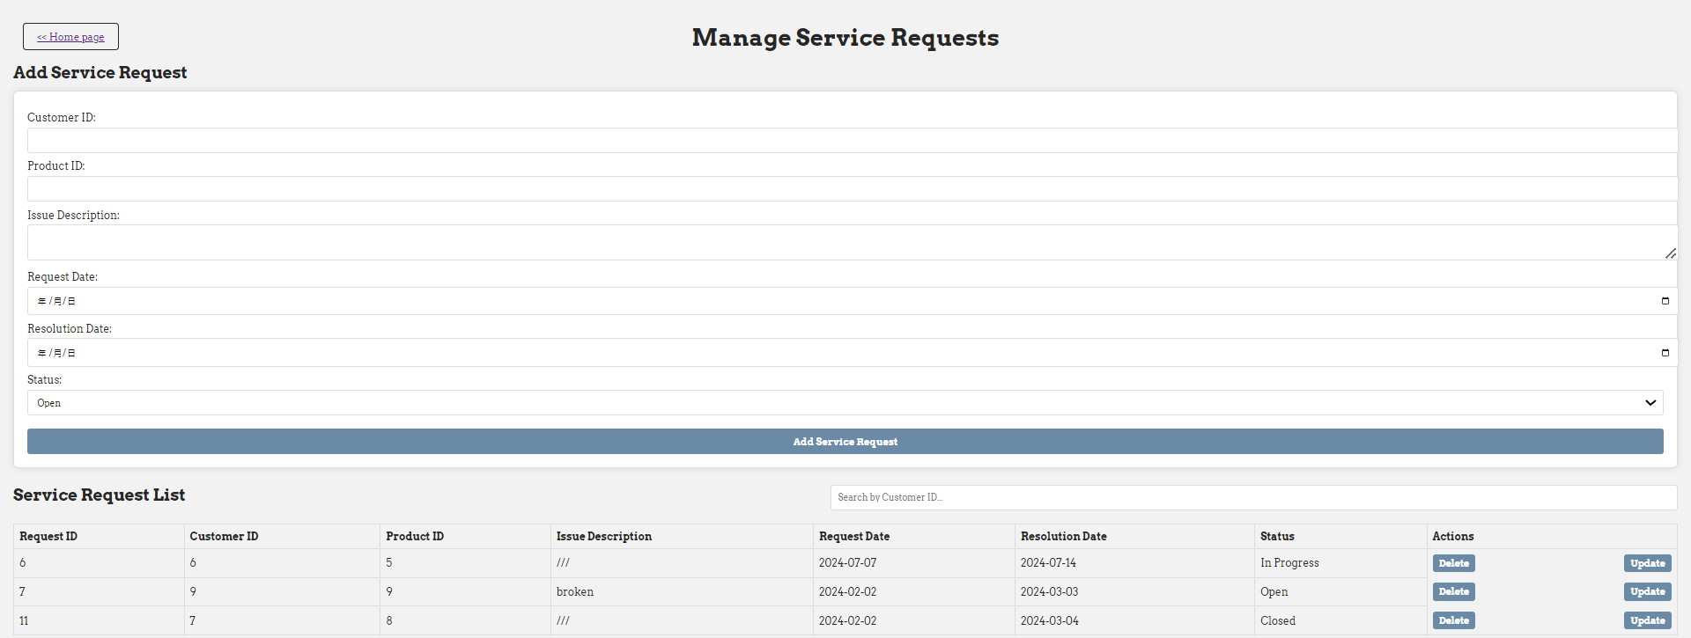
V | - Interaction Records  Log all customer interactions to provide a history of customer communications and preferences. | 